

MicroLink Information Technology College
Department of Computer Science

Student Teaching Performance Evaluation and Information System
[STPE-IS]
System Design Document (SDD)
For MicroLink Information Technology College

Prepared by:

- Asnakech Seleshi
- Fikre Berhanu
- Degalem Zeleke
- Fatuma Mohammed
- Marta Abebe

Advisor:

Epherem Tilahune

August 14, 2021
Table of Contents
1. Introduction 2
1.1 Purpose 2
1.2 Scope 2
1.3 Definitions, acronyms, and abbreviations 3
2. References 4
3. Goals and Trade-offs 5
3.1 Goals 5
3.2 Trade-offs 5
4. System Decomposition 6
4.1 Layers and Partitions 7
4.2 System Topology 8
4.3 Component diagram 9
5. Concurrency Identification 8
6. Hardware/Software Allocation 10
6.1 System Performance 11
6.1.1 General system performance 11
6.1.2 Input/output Performance 11
6.1.3 Processor allocation 11
6.1.4 Memory allocation 11
6.2 Connectivity 12
6.3 Network architecture 13
7. Data Management 13
8. Global Resource Handling 13
9. Software Control Implementation 14
9.1 External control flow (between subsystems) 14
9.2 Concurrent control 14
9.3 Internal control (within a single process) 14
9.4 User Interface 15
10. Boundary Conditions 17
10.1 Initialization 17
10.2 Termination 17
10.3 Failure 17
11. Design Rationale 17

System Design Document

Introduction
This paper, which is a system design document (SDD), describes designs developed for the proposed system whose requirements were collected and analyzed and were presented in the Requirement Analysis Document (RAD). It briefly shows how the system will operate and benefit of the proposed system from the manual systems.
This project helps Microlink Information Technology College to manage their Instructor performance evaluation process. The system has six user’s types, which are the System Admin, Academic Dean, Department Head, Student, Student Dean and Instructor. The System Admin user is in-charge of maintaining and managing the entire system. The Department Head user upload and populate the data in the system database using the front-end feature such as the list of courses, instructors, students, and some other related data. The student users are permitted to evaluate the instructor, review and upload complaint and application letters, follow-up teaching performance status that are assigned to their class per course, which means if the Microlink information technology college teaches the student three courses, the student will evaluate the instructors three times. The Student Teaching Performance Evaluation and Information System users are only allowed to view their evaluation result even though the evaluation is still ongoing. The system evaluation result will be based on the system default academic year which can be managed by the Department Head on the academic page. The evaluation questionnaire is dynamic in this system, which means the Department Head can create the questions and arrange the order of the questions per evaluation criteria.

1.1 Purpose

The general purpose of this system is to create a simple, reliable, efficient and online both web-based and android-based Student Teaching Performance Evaluation and Information system.

1.2 Scope
To develop an online Student Teaching Performance Evaluation and Information System, the Department Heads are in charge of the configuration of the system such as setting up the appropriate semester and academic year as well as indicating the valid dates of evaluation. And also, responsible for importing the master list of college instructors and registered students. The System Admin also imported master lists are used to verify user accounts and ensure that only authorized users are able to use the system. All the needed data such as instructors name and courses handled, student name with their sections, and their enrolled courses are managed by the Department Heads. The evaluation process is undertaken once every semester through an internet connection range set-up.
- Admin Module
- Website Includes
- Links to Menu list
- Links to Subject, Evaluation criteria, Questionnaires, and Evaluation report, Students, Instructors, Evaluation Result, Student Dean, and Academic Dean and Department Head.
- Deliverables
  - Upload complaint and application letter
  - Post announcement and information
  - Generate Evaluation result
- Assumptions
- Work in any environment as far as there is an internet connection.

1.3 Definitions, acronyms, and abbreviations

Students | A person who evaluates the instructor effectiveness, send complaints and application letter request.
Student Dean | A person who is responsible to review complaint letter.
Department Head | A person who feed all necessary information’s on the system, review evaluation rate, post information and other announcement.
Instructor | A person that give courses to the students.
Academic Dean | A person who review evaluation result, post announcement and information.
System Administrator | A person who has responsible to manage the entire system.
Users | Students, Student Dean, Departments, Academic Dean and Instructors.
IT | Information Technology
Android | Is Mobile operating system.
CSS | Cascading Style Sheet used to format the layout of web page.
Database | Is an organized collection of data
Javascript | Is a programming language that is used to create application for android
MySQL | Is a relational database system
PHP | Is a scripting language and used to develop dynamic web application together with MySQL, HTML, CSS and Java Script.
WAMP | Window Apache MySQL PHP
STPEIS | Student Teaching Performance Evaluation and Information System
FR | Functional Requirements
NFR | Non- Functional Requirements
RAD | Requirement Analysis Document
GUI | Graphical User Interface

References

- Object Oriented Software Engineering -Using UML, Patterns, and Java; Bernd Bruegge & Allen H. Dutoit, Published by Pearson Education Inc., 3rd Edition.
- System Analysis and Design; Alan Dennis & Barbara Haley Wixom &Roberta M. Roth, Published by John Wiley & Sons Inc., 5th Edition.
- Object Oriented Software Engineering; Instructors Course Handout, Unpublished.
- Senior Final Project Document -RAD Template, Unpublished.

Goals and Trade-offs

3.1 Goals
- Functionality: The basic functions of the system are to create a platform that used to reduce the burden of maintaining all the records of the student teaching performance evaluation and information details of who studies in MicroLink IT College. In addition to this, the platform creates easy methods of inserting, retrieving and updating the evaluation and information details for users.
- Usability: Our system should be user friendly by having simple interfaces, which are interactive and give understandable messages incase errors occurs.
our system is design to have user-friendly interface or easy to use.
- Efficiency: Our system is designed to use resources efficiently. For instance, the system will avoid unnecessary use of memory and storage by prohibiting background tasks as much as possible and store resources by compressing them. This significantly makes our memory and storage usage efficient.
- Security: With respect to the security, our system will have authentication for each user’s personal information, including username and password, which will be encrypted when they are stored in the database. To protect the database from different attacks, the software will be connected to the database.
- Database Management: The MYSQL database and WAMPP server are the most important part of this system. The database is also designed to include future extensions whenever database modification is needed and increase the data required for transactions.

3.2 Trade-offs

Rapid prototyping vs. completeness of functionality:
Our priority focuses on completeness of functionality of the system following the rapid development. The design illustrates the total functionality of the system and how they are implemented for the android application.
Usability vs. functionality
Since making, many functions in one interface is an annoyance for the user that makes interfaces more difficult to learn and use. Therefore, our system alleviates this problem by allocating specific and similar tasks on one interface.
Efficiency vs. portability:
Our application will run in any android operating system and can be transferred from one android mobile environment to another with a good use of processor and memory.
Cost vs. Reliability:
For the reliability of the software tests, will write for the main function to make it error free. In addition, all these possible and predetermined errors from the user side will be handled without affecting the cost of the system.
Reusability vs. Cost

To make the development cost our classes and functions are designed to be reused in the code, we will not write the classes with some functions two times; rather, we follow the design pattern that forces us to use the re-usability of the code. This saves the development time, which leads to decreasing the development cost.

System Decomposition
The student teaching Performance Evaluation and information mobile application is developed to enhance the existing manual platform and will have user registration, user login, teaching performance evaluating, post announcement and information, send complaint and application letter. This will make the system to full fill the functionalities of the designed system.
- User Login sub system: This sub system helps users to authenticate themselves and distinguish what to access and what to display in their home page.
- User Registration sub system: This system allows users to register and to create an account.
- Search: To search the detail of the required project click the search button then sub system allows users to search student and instructor in different parameter.
- View reports: To view records from the database click view report button, then it will open.
- Delete: To delete the record from the database the system administrator can delete the row corresponding to records he/she want to delete.

4.1 Layers and Partitions
User Registration
The user registration needs a storage to store information about users (Student, Student Dean, Instructor, Department Head, Academic dean and System Admin) and the system should check the validation of the account created from the database.
Login
The system authenticates the user; if the user failed to enter the right information, the system replies with a custom error message for the user. This sub system is depending on the User Registration sub system.
Post Announcement and Information
This subsystem allowed the department head and academic dean to post the announcement and information.
View Evaluation Result
This subsystem allowed an instructor, Department Head, an Academic dean and a System Admin to access the evaluation result, details of the instructor as per the evaluation requirements.
View Complaint and Application Letter
This subsystem is allowed to view complaint and application letters which are posted under this system to be accessible for the Department Head, Academic Dean and Student Dean.
View Announcement and Information
This subsystem is allowed to view announcement and information that are posted under this system to be accessible for the Department Head, Academic Dean, Student and Instructor.

4.2 System Topology

a. Component diagram
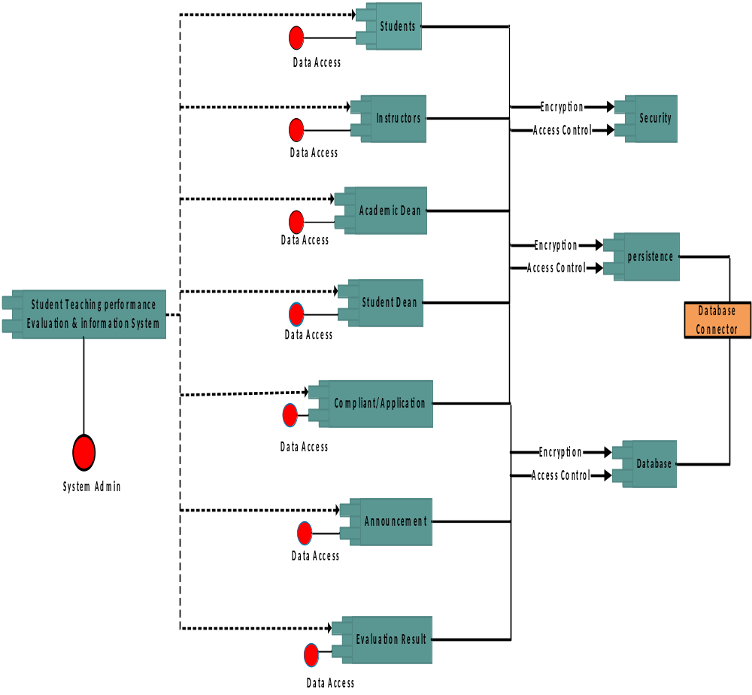

b. Deployment Diagram

Database server

Web Server

Application server

Student
PC

Department Head
PC

Student Dean
PC

Instructor
PC

Academic Dean
PC

System Admin
PC

5. Concurrency Identification
The system provides access to multiple users. Users on different machines will be able to access the system with specialized software. The database servers are multi-threaded and in this way can handle demands from several users at a time. Consequently, the network should be strong enough to reach such an expectation.

A single query consists of two or more queries since a job is composed of several entities. Such as course, Courses offering, Departments, Section, Evaluation Questions, revaluation results, announcements & information, instructors, admin and staff and students which are stored separately. The execution of queries will not be handled in parallel by different subsystems. The rationale for this kind of design is that we do not have the necessary hardware or the traffic load to necessitate this. And it would also take a long time to develop this kind of system.

6. Hardware/Software Allocation
- Hardware requirement for server side:
  - Processor: 8 Core, 3.20GH_{z}
  - Secondary Storage: 2TB HDD
  - ROM: 52X CD ROM Drive
  - Memory: 16GB RAM
  - Network Adapter: Ethernet Adapter
  - Modem: 5mbps
  - Others: 17” Color Monitor, Printer, Keyboard, Mouse.
  - The system needs to be operating 24 hours; hence, power supply should be 100% assured.
- Software Interface for the server side:
  - Platform: Windows, Latest versions are recommended
  - Operating System: Windows 8 and above
  - Framework: PHP Laravel framework
  - Back-end tool: JavaScript
  - The system has PHP v5.0 that is used to load and compile server side scripts
- Software Interface for the client side
  - Mobile android operating system above API 21
- The system browser should be JavaScript enabled so that it uses JavaScript for client side scripting
- and compilation of WebPages.
- The system browser should be JavaScript enabled so that it uses JavaScript for client side scripting
- and compilation of WebPages.
  - The system browser should be JavaScript enabled so that it uses JavaScript for client side scripting and compilation of Webpages.
- The system browser should be JavaScript enabled so that it uses JavaScript for client side scripting
- and compilation of WebPages.

System Performance

General system performance

The system is expected to respond to requests within a few seconds not exceeding 4-8 seconds. For tasks that may take longer it is desired to respond in the 1-minute else request the user to reload.

Input/output Performance
There is no need for extra hardware to handle the data generation rate of the system. The existing communication bandwidth is sufficient to support all the communication between subsystems.

Processor allocation
The computation rate is very small compared to other applications that the deployment system’s process can handle normally

Memory allocation
There is enough memory to handle requests. The traffic generated by the application is medium.

Connectivity
Connectivity Diagram
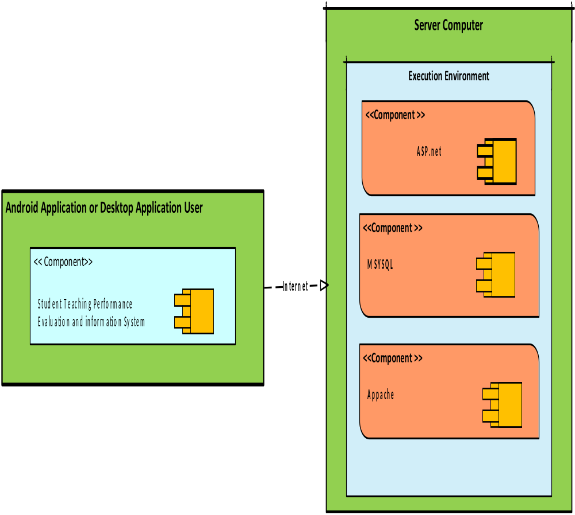

Network architecture
The general interaction mechanism and protocol for the channels and the communication are synchronous communication so that the server should be available for the client, otherwise the communication will be disconnected. The expected bandwidth for the networking is 20MB/S.

7. Data Management
Data generated by the application will be managed by a relational database management system. MySQL which stores its databases on the server secondary storage. The data are centralized. In the worst scenario, the average request rate is estimated to be 2000 requests per min.
To enforce data integrity, we implemented the following relationship constraints.

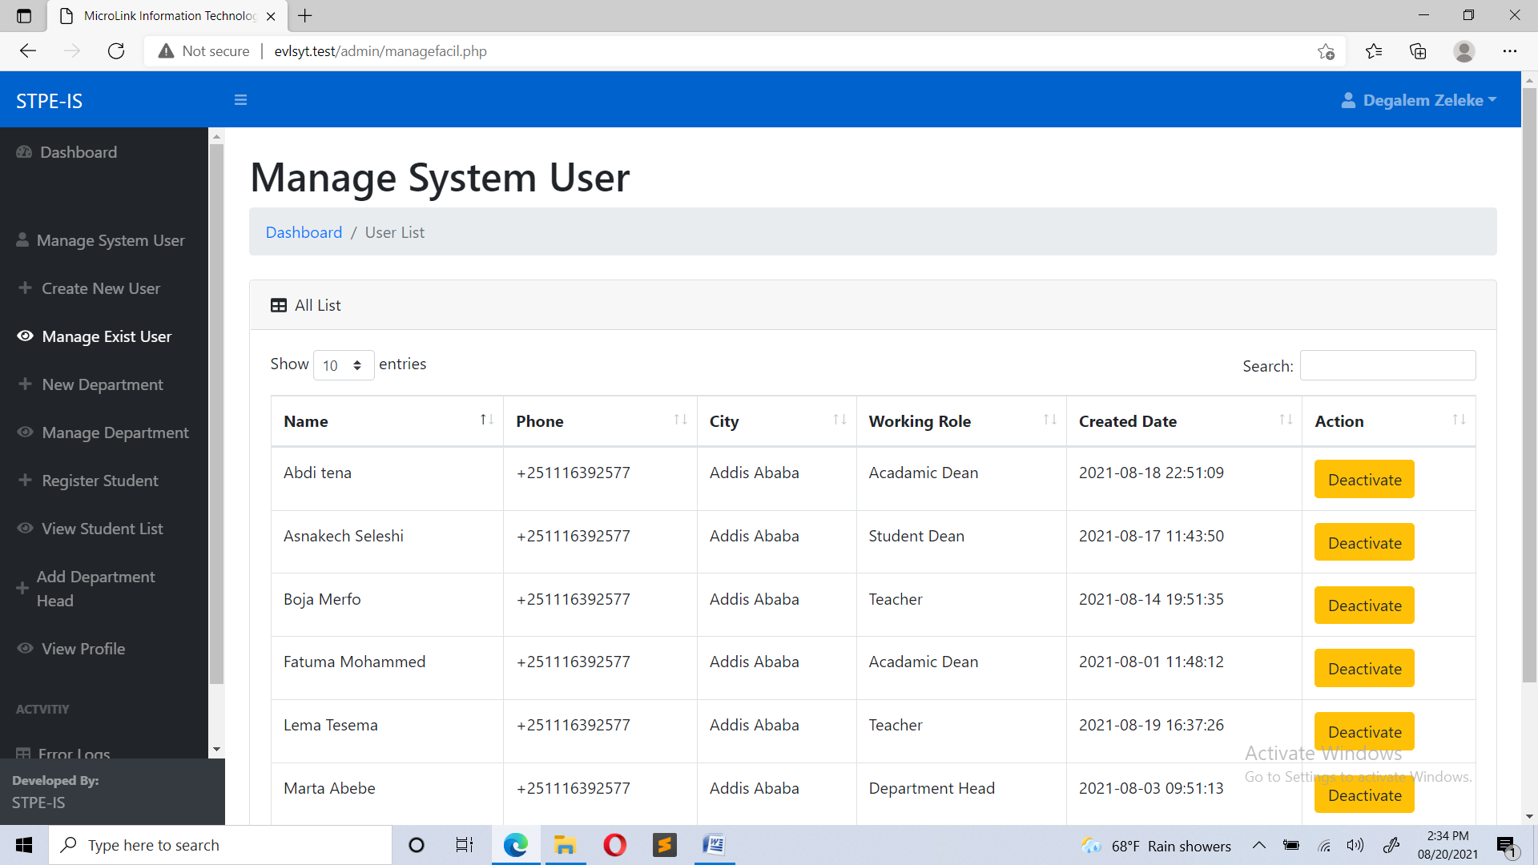

Global Resource Handling
The system provides authentication. The user session is handled by writing the authentication scheme that the system will use, which is a basic authentication scheme which sends a Base64-encoded string that contains a user name and password for the client. Base64 is not a form of encryption and should be considered the same as sending the user name and password in clear text. The user interface for authentication is a user to input his/her username and password, and there are no hardware mechanisms to control access.

The system will run on a network whose nodes are assigned an IP address that is leased yearly based on a period. Authentication endured that only authenticated and authorized users access the space.

Software Control Implementation

External control flow (between subsystems)
The MVC (model view controller) which we use for the system makes the subsystems very intuitive. The model is always responsible for the data handling and the view is responsible for displaying the data. And the controller is responsible for controlling the application logic and acts as the coordinator between the View and the Model. So, there are procedures which request input, one example is posting an announcement. Since posting and an announcement to the network takes some time, therefore, the posting announcement resumes when the posting message is completed.

Concurrent control

There are subsystems that can run concurrently. One example is while uploading assignment and solution, and posting event and announcement complete, the user can view other information. And until one user requests to view information, he/she can view other information in the accessible list page. Tasks that need fetching or submitting to the request are done asynchronously, other tasks can be done in a parallel direction.

Internal control (within a single process)
The process control system is implemented by system calls to the underlying script execution engine. when the user clicks one controller from each screen the system displays the corresponding page for the user.

9.4 User Interface
Some of the user interfaces are shown below:
- Login UI



- System Administrator Home screen UI

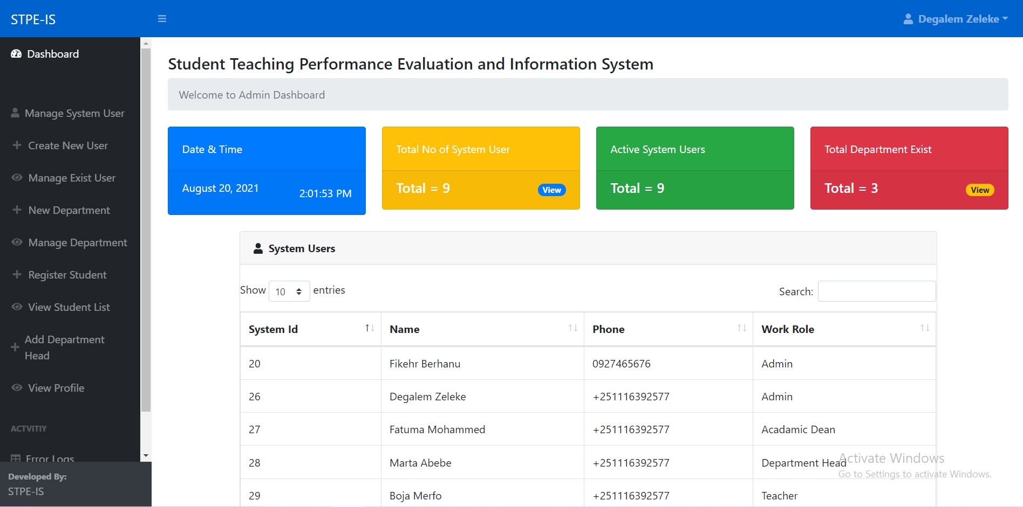

- Student Registration UI

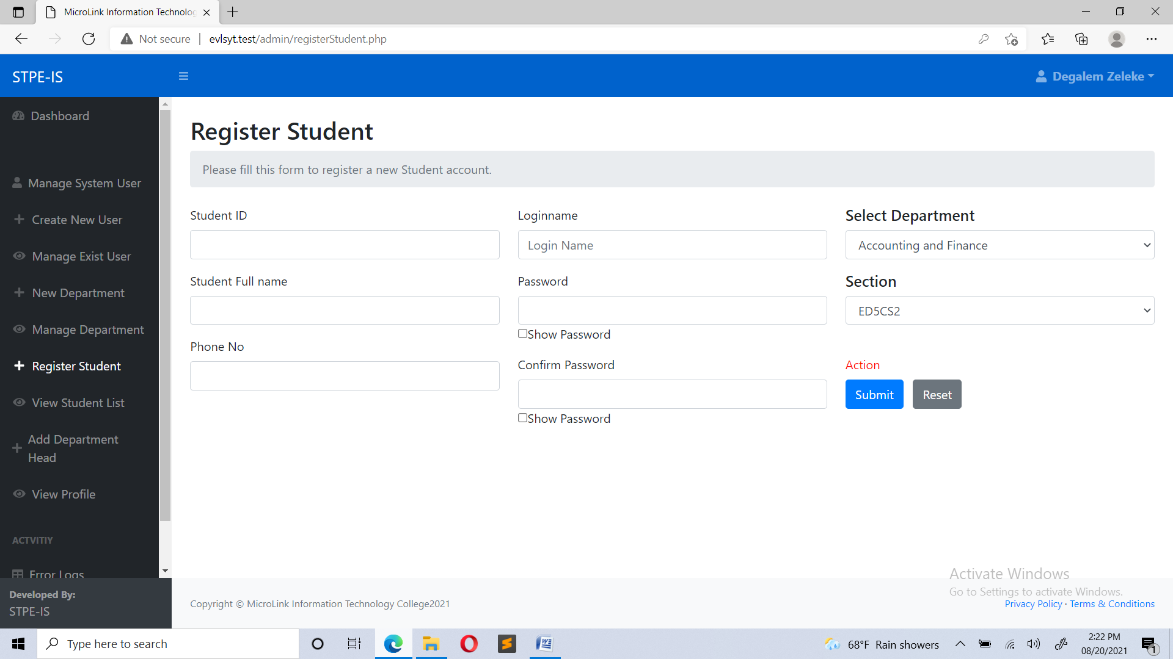
- Student Teaching Evaluation Form

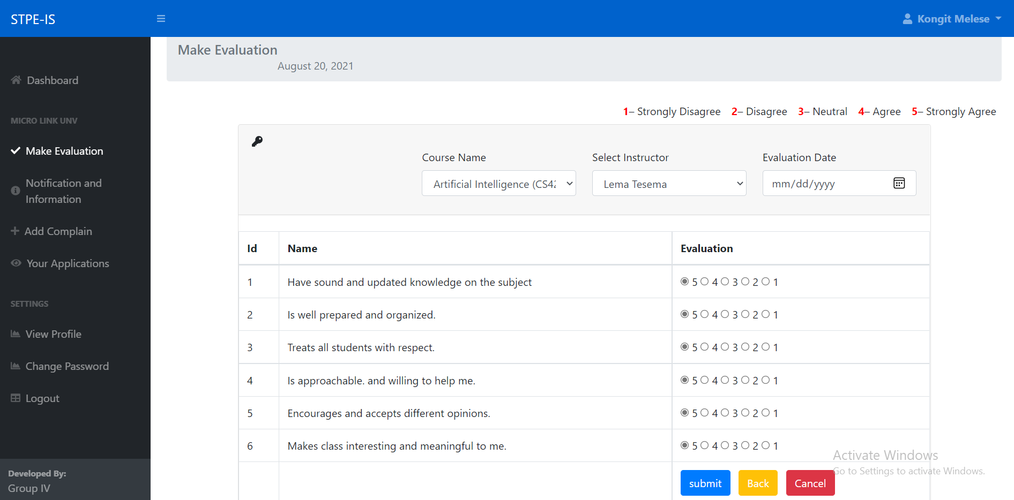

Boundary Conditions

Initialization

The system can be viewed from a mobile or desktop or tablet view since it is a responsive web-based system. One’s user signed in to the application, there is no need to login unless he or she or she wants to. So, after the first login, the data to be user token data should be accessed at the start-up time. The user interface shows the logo of the application until full resources are loaded.

Termination

The Termination conditions for the system are as soon as the users sign out or destroy the lifecycle of the application. At the time of termination, subsystems will be notified of any action they need to perform. Database connections will be closed. Database commits will be done by the subsystems when the system terminates.

Failure

Any incomplete transaction will be rolled back to the point where it was before the system process started.

. Design Rationale
The reason we choice MVC than the other design architecture patterns are:
- Maintainability

  - The system will be maintained periodically through effective monitory and evaluation. This will go a long way to help identify and debug emergency production problems and address them accordingly. A considerable amount of time would be spent to effect changes in data, files, reports, hardware and software.
  - That means we can remain agile and keep moving out to new releases quickly.
  - The system can easily identify and fix the errors within the software components.
- Testability
- Two types of testing will be performed to test the website and how it supports mobile working. These tests were mainly performance testing and functionality testing.
- Performance Testing
The website was tested on Firefox browser using an online tool called GTMetrix, which analyzes web pages according to different rules by giving each rule a weigh, and then evaluate the score of each rule for the website. The rules tested by this tool is indicated in Table blew
- Functionality Testing
All functions in the application, database connection, forms used to enter data for submission, editing, getting or deleting information from users were tested. Developers performed the test of the website. Some functionality requirements were tested during the test of security and Database of the system test.The system can evaluate teachers performance online as its main function. It can also yield a results or reports. The result can be received via email or can be printed or viewed.
- Extensibility
  - we will have a better chance of making any of those parts more reusable.
  - It has also the ability to replace or add new pieces of code that do similar things into the right places in the architecture.

